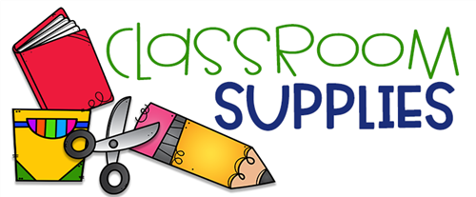

* 1 regular size backpack labeled with your child’s name
* 2 rolls of paper towels
* 1 package of Expo dry erase markers
* 1 box of 24 Crayola crayons
* 1 box of 8 ct. Crayola crayons
* 1 box of thick Crayola washable markers
* 1 box of thin Crayola washable markers
* 3 bottles of Elmer’s glue 4oz
* 1 trifold plastic rest mat
* 1 pocket folder
* 4 Elmer’s washable glue sticks (disappearing purple)
* 4 containers of 16oz Play-Doh (any color)
* 1 one subject spiral notebook
* $3.00 for heavy duty communication homework folder
* **1** complete change of clothes including a shirt, pants (no skirts), socks, and underwear packed in a bag labeled with your child’s name. These clothing items are necessary in the event of an accident and will be stored in the classroom.